Rantoul Foods  USDA Establishment 31559  205 Turner Drive  Rantoul, IL 61866 | Updated:00  Implemented: 06/13/11
PRODUCT SPECIFICATIONS

Product Code: 4701
Product: Pork Boneless Boston Butt
Cutting/Boning Instructions  Trim Specs: 1) Trimmed to 1/4”. Not to exceed 3/8” above false lean. 2) External visible glands removed. 3) Jowl tip is removed at anterior end of butt, however false lean cap is allowed to remain over the top surface of the butt.  Wt/Size Spec: None  Primal Specification: Shoulder/Middle separation is removed from shoulder via a straight cut between the 1st and 2nd rib. Picnic/Butt separation: Immediately atop the Humoral/Scapular articulation. Cross section of blade bone above joint is visible.  Further Butchering Procedures: The product is then trimmed to a 1/4” fat cover. Visible glands at neck end are removed. 3) The blade bone and any remaining humerous bone are removed completely.  .  Additional Description: 1) Pie scapulary lymph gland can remain if not exposed. 2) No bone chips / cartilage. 3) Butts are bagged sideways with the neck ends facing towards each side of the bag. | Packaging Specifications  Storage: Maintain Fresh  Pack Style: COV / BOX
Bag Use/Fze by date: NO
Box Use/Fze by date: NO

Case Wt: 60# (lbs.) catch weight

Pcs/Bag: 2

Bags/Box: 4

Quality Control:  Critical Defect Criteria 1) Presence of bone chips / hard cartilage. 2) Fat cover exceeds 1/2” on all surfaces. 3) Presence of glands. 4) Presence of skin.  Major Defect Criteria 1) Presence of hard cartilage 2) Fat cover on the cap exceeds 3/8”. 3) Presence of glands.  Minor Defect Criteria 1) Presence soft cartilage. 2) Fat cover exceeds 1/4” | Quality Control Measures:  1) Routine Butt audits by QC.

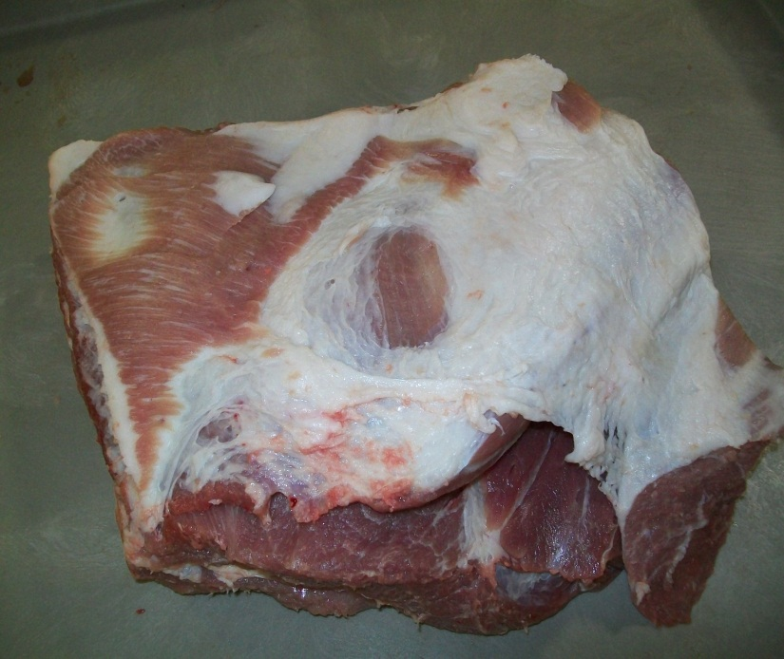 | 