Rantoul Foods  USDA Establishment 31559  205 Turner Drive  Rantoul, IL 61866 | Updated:00  Implemented:06/13/11
PRODUCT SPECIFICATIONS

Product Code: 4290
Product: Pork Bone-In Picnic, SS (Short Shank)
Cutting/Boning Instructions  Trim Specs: 1) Sanitation Trim on skin surface. 2) Skin and fat beveled where it meets lean. 3) Soft globby fat is trimmed flush with lean.  Wt/Size Spec: Whole pieces only  Primal Specification: Shoulder/Middle separation is removed from shoulder via a straight cut between the 1st and 2nd rib. Butt/Picnic separation: Immediately atop the Humoral/Scapular articulation. Cross section of blade bone above joint is visible. PICNIC/BUTT SEPARATION: Immediately atop the Humoral/Scapular articulation. Cut parallel to the split side. FOOT SEPARATION: Atop metacarpus bones. Hock is removed 3” above the cut-off point, leaving approximately a 2” shank on picnic.  Further Butchering Procedures: 1) Short shank. 2) Breast flap with overlying skin is faced (Roundhouse action from anterior to posterior end of picnic immediately above armpit). 3) On side separated from the butt, skin and fat is beveled back ½”-3/4” at a 45 degree angle. 4) Chop side near the elbow to remove fatty pocket if present.  Additional Description: 1) Shank is approximately 2-2.5” as measured from edge to the end of the hock. 2) A view of the hock end cross section should show 40-50% bone and skin and 50-60% meat, fat and connective tissue. | Packaging Specifications  Storage: Fresh  Pack Style: Combo
Bag Use/Fze by date: NO
Box Use/Fze by date: NO

Case Wt: (2000 lbs.) Catch weight.

Pcs/Bag:

Bags/Box: 1 combo liner

Quality Control:  Critical Defect Criteria 1 Presence of foreign material. 2) Hock length exceeding of 3”. 3) Presence of hairs in excess of 50 hair strands per piece.  Major Defect Criteria 1) Presence of hairs not in excess of 50 hairs per piece. 2) Hock length exceeding 2.75”.  Minor Defect Criteria 1) Fat on any exposed surface in excess of ¼” covering an area which measures at least 1”X1”. 2) Shank length exceeding 2.5”. | Quality Control Measures:  Routine QC Inspection prior to bagging.

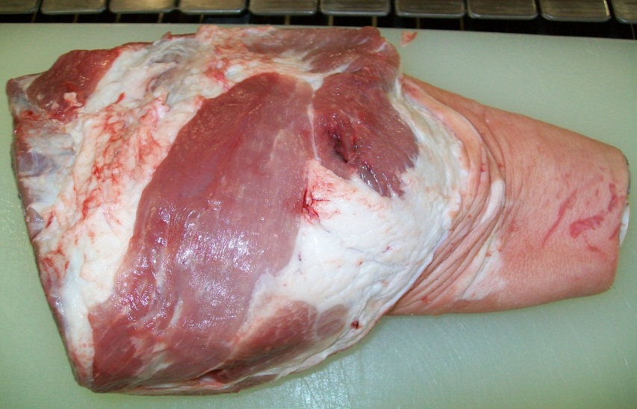 | 