Rantoul Foods  USDA Establishment 31559  205 Turner Drive  Rantoul, IL 61866 | Updated:06/26/12  Implemented:06/13/11
PRODUCT SPECIFICATIONS

Product Code: 1370
Product: Pork Bone-In Loin, CC (Center Cut)
Cutting/Boning Instructions  Trim Specs: 1) 1/4” fat max on the fat side, it can not to exceed 3/8”over s addle area. 2) Channel area: Fat covering tenderloin cannot exceed 1/8”. 3) Remaining spinal cord material removed.  Wt/Size Spec: 11 ribs of length  Primal Specification: Shoulder/Middle separation is removed from shoulder via a straight cut between the 1st and 2nd rib. Ham is removed from middle 1.25” anterior to the aitch bone. 4” scribe width measured from the junction of the 10th rib with the chine to the sawed edge.  Further Butchering Procedures: 1) Sirloin end removed anterior to the hop bone (between the first sacral and last lumbar vertebrae) leaving no hip cartilage in the loin. 2) Rib end removed to make an 11 rib count. 3)Chine bone remains  Additional Description: 1) Sirloin-Out 2) Tender-in 2) Rib End removed / 11 rib count. 3) Chine Bone remains. 4) Feather bones remain attached. | Packaging Specifications  Storage: Maintain Fresh  Pack Style: COV/BOX
Bag Use/Fze by date: NO
Box Use/Fze by date: NO

Case Wt: (lbs.) catch weight

Pcs/Bag: 2

Bags/Box: 2

Quality Control:  Critical Defect Criteria 1) Scribe width is greater than 5” or less than 3” at the 10th rib. 2) Fat cover exceeds 3/8” over any area greater than 2 square inches. 3) Scores in fat exposing lean in an area exceeding 4 square inches.  Major Defect Criteria 1) Fat cover is greater than 1/4”. 2) Scores exceeding an area of 2x4”. 3) Scribe width is greater than 4.5” or less than 3.5” at 10th rib. 4) Presence of hip cartilage left in posterior end of loin.  Minor Defect Criteria 1) Fat cover is greater than 1/8”. | Quality Control Measures:  1) Routine Loin QC audits

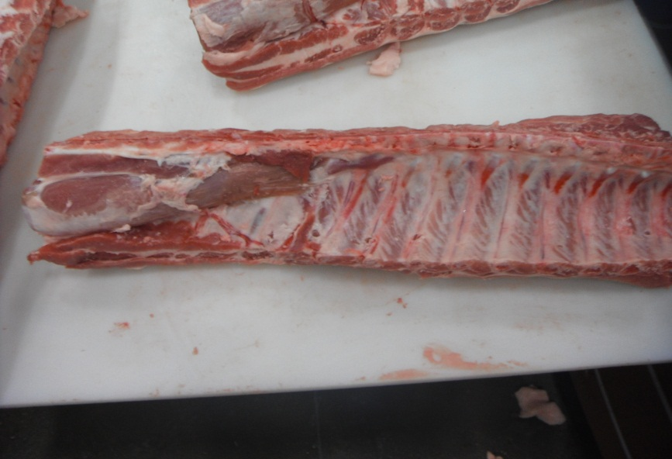 | 